Iterative and Recursive Methods
Program:
#include <stdio.h>

// Iterative Method
long long factorialIterative(int n)
{
long long fact = 1;

for (int i = 1; i <= n; i++)
{
fact = fact * i;
}

return fact;
}

// Recursive Method
long long factorialRecursive(int n)
{
if (n == 0 || n == 1)
{
return 1;
}
else
{
return n * factorialRecursive(n - 1);
}
}

int main()
{
int n;

printf("Enter the value of n: ");
scanf("%d", &n);

if (n < 0)
{
printf("Factorial is not defined for negative numbers.\n");
}
else
{
// Iterative factorial
printf("Factorial using Iterative Method = %lld\n",
factorialIterative(n));

// Recursive factorial
printf("Factorial using Recursive Method = %lld\n",
factorialRecursive(n));
}

return 0;
}

OUTPUT:
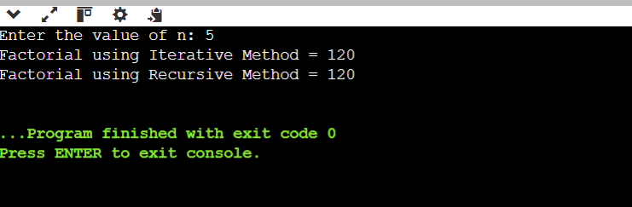
Conclusion:
Method | Best Case | Average Case | Worst Case | Space Complexity
Iterative Factorial | O(n) | O(n) | O(n) | O(1)
Recursive Factorial | O(n) | O(n) | O(n) | O(n)

